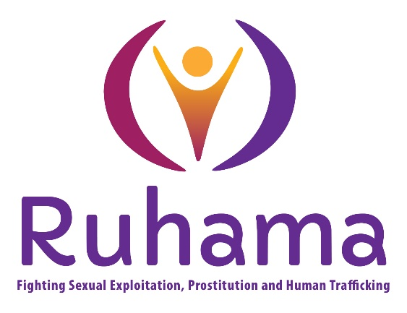

Invitation to tender for a National Public Awareness Campaign on Prostitution, Pornography, and Sexual Exploitation

Date 3rd November 2025

Ruhama Request for Services
Consultancy for Ruhama’s National Public Awareness Campaign on Prostitution, Pornography, and Sexual Exploitation.

1. Introduction
Ruhama invites proposals from experienced campaign and research consultancies to devise and manage all aspects of a proposed national public awareness campaign on prostitution, pornography and sexual exploitation. This will comprise 2 phases: firstly, the development of comprehensive research tools to generate evidence-based insights which will inform and guide a future public awareness campaign, and secondly, the development of a campaign strategy and messaging content for this campaign.
The successful consultant will at all phases of this project work in close collaboration with Ruhama both in devising the research approach and in the development of the strategy and messaging content. The ultimate objective of the project is to inform the public on issues around sex purchase, the legislative landscape in which it occurs and the supports available to individuals within the sex trade. It will ultimately seek to change behaviour around the consumption of pornography and the purchase of sex, and to move the dial on public tolerance for same.

2. Background of the Organisation
Ruhama is a National NGO providing support services to women impacted by prostitution and human trafficking for sexual exploitation. Ruhama provides wrap-around support for women, (the sex trade is a highly gendered phenomena) which supports them in dealing with the immediate impacts of trauma, through various support mechanisms. We work to identify positive goals for the future and through educational and personal development work towards independent living and mainstream employment opportunities. Services are offered based on each individual women’s needs using a trauma informed approach. Ruhama also advocates to influence policy that supports and protects women.

3. Campaign Consultancy Objectives
- Lay out the current context relating to research findings on the issue of pornography consumption, prostitution in Ireland and the links to sexual violence and sexual exploitation
- Measure public knowledge of the Criminal Law (Sexual Offences) Act 2017 relating to prostitution
- Measure public support for various aspects of the Criminal Law (Sexual Offences) Act 2017 relating to prostitution
- Measure public attribution of particular social harms (such as poor understanding of consent) to the increased consumption of pornography
- Measure the understanding of prostitution as a cause and consequence of gender inequality
- Measure the public understanding of the violent nature of prostitution for the women involved
- Develop and test alternative messaging approaches for campaign effectiveness
- Provide audience segmentation and analysis of all results
- Provide a detailed campaign strategy and evidence-based messaging content

4. Deliverables
The successful consultancy will be expected to produce the following:
(a) A comprehensive report on public attitudes to issues surrounding prostitution and pornography
(b) Supporting data, analysis, and presentation materials as appropriate
(c) A campaign strategy aimed, and messaging content aimed at achieving behavioural change

5. Budget
The total budget for this project is €82,000 including VAT. This amount must cover all consultancy fees, research costs, and associated expenses. Part of the evaluation of submitted Tender Proposals will be assessed against these criteria.

6. Proposal Requirements
- An overview of relevant and prior experience and expertise.
- Proposed methodology and timeline.
- Team structure and key personnel.
- Budget breakdown and justification.
- Examples of previous relevant research & campaigns.
- Capacity to deliver project in proposed timeline Dec 25-May 26.

7. Evaluation Criteria
- Demonstrated expertise in campaign-related and social research.
- Quality and robustness of proposed methodology.
- Demonstrated understanding of the research objectives.
- Cost-effectiveness and value for money.
- Experience of the proposed team.

8. Submission Instructions
Initially the tender proposals will be checked for compliance with the Request for Tender conditions. Potential consultants will be assessed both on their tender proposal and if required, a follow up interview. They will be assessed against the following major attributes*:

- Proven capability and prior experience in research, consultation, and relevant field of work (250).
- Proven capability and prior experience in the development of a campaign strategy and messaging content for campaigns (250).
- Capacity to deliver project in proposed timeline Dec 25-May 26 (250).
  - Methodology (250).
  - Cost (200).

*A minimum threshold of 100 in all categories will be a necessary requirement.

- Provide overall costings inclusive of hourly/daily rate, travel and VAT
- The proposal document should not exceed 4,000 words
- The successful applicant will be asked to provide a current Tax Clearance Certificate and Professional Indemnity Insurance at contract stage. It is expected that shortlisted applicants may be invited to make a presentation to the Senior Management Team prior to any decision to confirm an appointment.

Proposals should be submitted electronically to:
Feargha Ní Bhroin
Email: policy@ruhama.ie
by Tuesday 02/12/2025 5pm
Questions or clarifications regarding this Request for Services should be directed to the same contact. Deadline for queries regarding the Request for Services by Thursday 20th November by 5pm

9. Copyright and Confidentiality
The consultant will be required to assign copyright of all materials and data to Ruhama. Copyright for any illustrations or other material used should be cleared by the consultant. Sections of the research report may be made available for public use by Ruhama. Authorship will be fully acknowledged.

Tenders received after the closing date will not be considered.

